Bildagentur für Kunst, Kultur und Geschichte.
Ahmad Hasan Ahmad
2023-04-27
Table of contents

1. Bildagentur für Kunst, Kultur und Geschichte
Author: Ahmad Hasan Ahmad
ORCID: https://orcid.org/0009-0008-4964-222X
Date: 28.04.2023
DOI: 10.5281/zenodo.7873444
Repository URL: https://github.com/Ahmad19111/catalogue-003

1.1 Based on Baroque AI: Publication Prototype

1.2 Part of the series: Baroque TOC
Programme instructions
2023-03-17
This work is licensed under a Creative Commons Attribution-ShareAlike 4.0 International License.
Book cover: Reworking of Baroque pearl with enamelled gold mounts set with rubies. Creative Commons CC0 1.0 Universal Public Domain Dedication. This file was donated to Wikimedia Commons as part of a project by the Metropolitan Museum of Art.

This work is licensed under a Creative Commons Attribution-ShareAlike 4.0 International License.

2. Colophon
- Fork title: Ahmad19111/catalogue-003
- Author: Ahmad Hasan Ahmad
- ORCID: https://orcid.org/0009-0008-4964-222X
- Date: 28.04.2023
- DOI: 10.5281/zenodo.7873444
- Repositor: https://github.com/Ahmad19111/catalogue-003
PUBLISHING FROM COLLECTIONS USES OF COMPUTATIONAL PUBLISHIGN AND LINKEDOPEN DATA
Open Science Lab - TIB Hannnover
First published 2023-03-30
Copyright © The Authors 2023 Licensed as https://creativecommons.org/licenses/by-sa/4.0/
DOI: https://doi.org/10.5281/zenodo.7701161

3. About the Museum
Source: https://de.wikipedia.org/wiki/Bildagentur_f%C3%BCr_Kunst,_Kultur_und_Geschichte

3.0.1 Bildagentur für Kunst, Kultur und Geschichte
The Picture Agency for Art, Culture and History (bpk) is an institution of the Prussian Cultural Heritage Foundation and was founded in 1966 as the Picture Archive of Prussian Cultural Heritage. The photo agency is housed in a house named after Otto Nagel on the Märkisches Ufer in Berlin’s Mitte district and claims to have twelve million photos, caricatures and drawings from the fields of art, culture and history.
In organizational terms, the photo agency is a department of the Berlin State Library.
Karen Tieth has been the head of bpk since January 2019.

4. Data Visualization
Visualization
Here an image of my data viz : 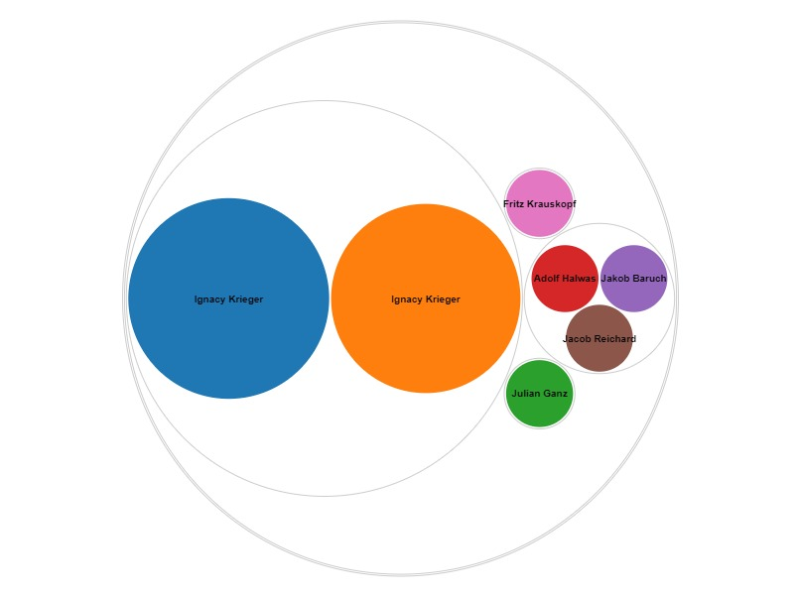
Here is an iframe with some data viz:

5. Historischer Porträtaufnahmen
Wikidata link: http://www.wikidata.org/entity/Q119217955
Title: Polish Rabbi
Year: 1870-01-01T00:00:00Z
Creator: Ignacy Krieger
Collection: Bpk-Bildagentur
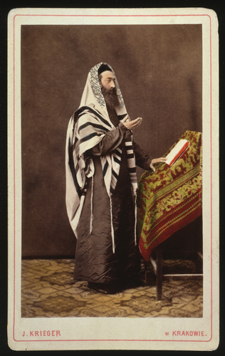
Wikidata link: http://www.wikidata.org/entity/Q119217956
Title: Young Pole in national dress from Lublin region
Year: 1870-01-01T00:00:00Z
Creator: Ignacy Krieger
Collection: Bpk-Bildagentur
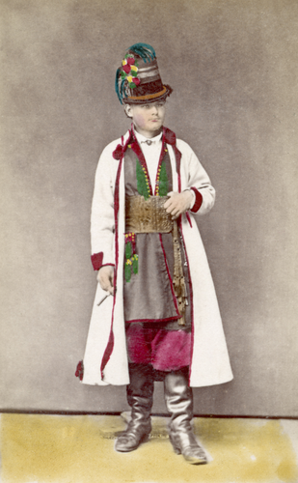
Wikidata link: http://www.wikidata.org/entity/Q119217957
Title: Old man from Plotska area
Year: 1870-01-01T00:00:00Z
Creator: Ignacy Krieger
Collection: Bpk-Bildagentur
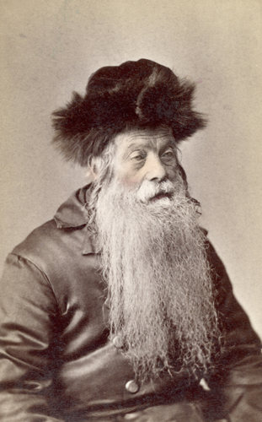
Wikidata link: http://www.wikidata.org/entity/Q119217958
Title: Polish couple in national costume
Year: 1870-01-01T00:00:00Z
Creator: Ignacy Krieger
Collection: Bpk-Bildagentur
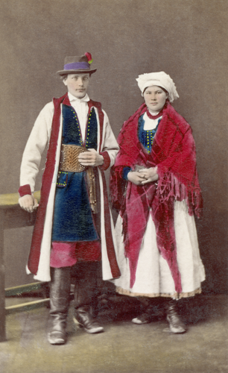
Wikidata link: http://www.wikidata.org/entity/Q119217959
Title: Male costume from the Lublin area
Year: 1870-01-01T00:00:00Z
Creator: Ignacy Krieger
Collection: Bpk-Bildagentur
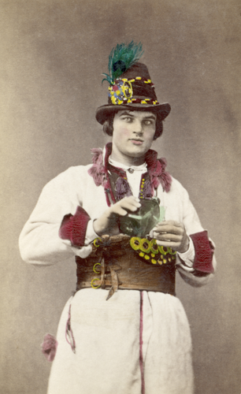
Wikidata link: http://www.wikidata.org/entity/Q119217961
Title: children’s costume
Year: 1870-01-01T00:00:00Z
Creator: Ignacy Krieger
Collection: Bpk-Bildagentur
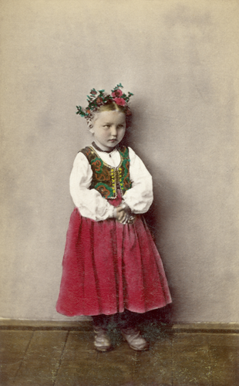
Wikidata link: http://www.wikidata.org/entity/Q119217962
Title: women’s costume
Year: 1870-01-01T00:00:00Z
Creator: Ignacy Krieger
Collection: Bpk-Bildagentur
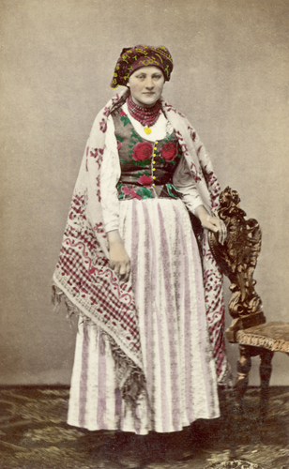
Wikidata link: http://www.wikidata.org/entity/Q119217987
Title: Couple in Sunday costume
Year: 1870-01-01T00:00:00Z
Creator: Ignacy Krieger
Collection: Bpk-Bildagentur
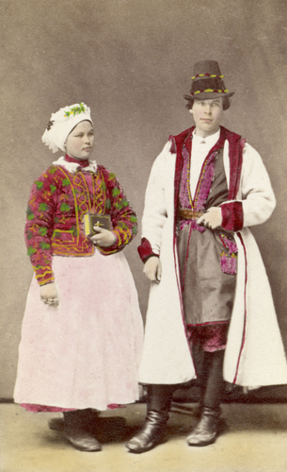
Wikidata link: http://www.wikidata.org/entity/Q119224407
Title: Couple in holiday costume
Year: 1870-01-01T00:00:00Z
Creator: Ignacy Krieger
Collection: Bpk-Bildagentur
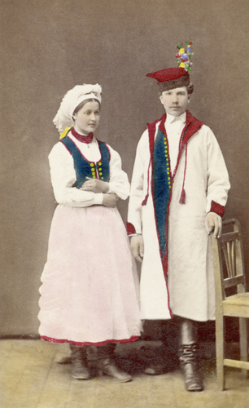
Wikidata link: http://www.wikidata.org/entity/Q119224408
Title: Festival costume of a young farmer
Year: 1880-01-01T00:00:00Z
Creator: Ignacy Krieger
Collection: Bpk-Bildagentur
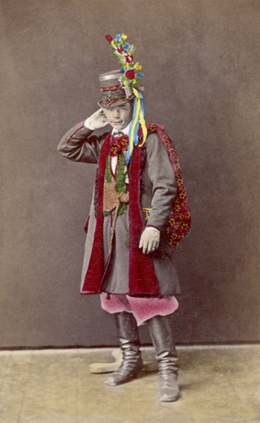
Wikidata link: http://www.wikidata.org/entity/Q119224410
Title: Clothes of a landowner from the Lublin area
Year: 1880-01-01T00:00:00Z
Creator: Ignacy Krieger
Collection: Bpk-Bildagentur
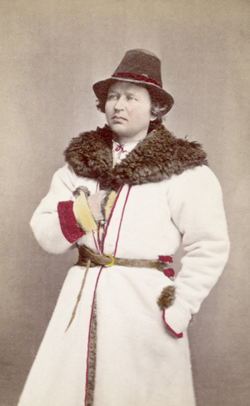
Wikidata link: http://www.wikidata.org/entity/Q119224411
Title: Itinerant saleswoman with wall mats
Year: 1880-01-01T00:00:00Z
Creator: Ignacy Krieger
Collection: Bpk-Bildagentur
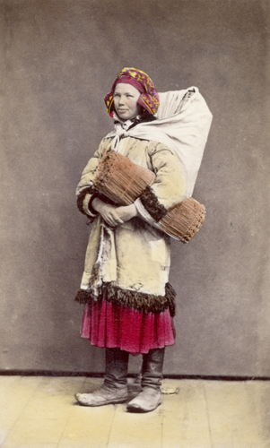
Wikidata link: http://www.wikidata.org/entity/Q119224412
Title: Costume of a Warsaw student
Year: 1880-01-01T00:00:00Z
Creator: Ignacy Krieger
Collection: Bpk-Bildagentur
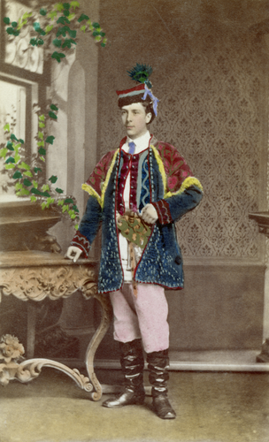
Wikidata link: http://www.wikidata.org/entity/Q119224414
Title: Coachman’s clothing
Year: 1880-01-01T00:00:00Z
Creator: Ignacy Krieger
Collection: Bpk-Bildagentur
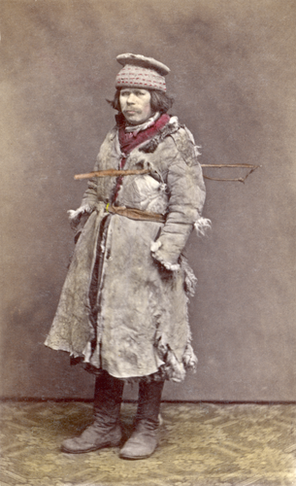
Wikidata link: http://www.wikidata.org/entity/Q119224417
Title: Costume of a peasant girl
Year: 1880-01-01T00:00:00Z
Creator: Ignacy Krieger
Collection: Bpk-Bildagentur
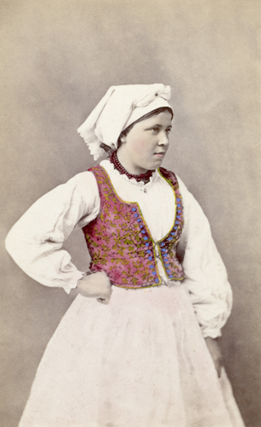
Wikidata link: http://www.wikidata.org/entity/Q119224419
Title: Shepherd’s costume
Year: 1880-01-01T00:00:00Z
Creator: Ignacy Krieger
Collection: Bpk-Bildagentur
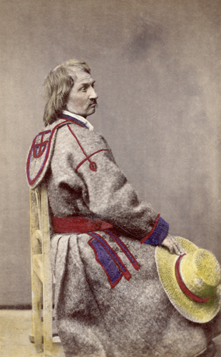
Wikidata link: http://www.wikidata.org/entity/Q119224499
Title: costume of a farmer
Year: 1880-01-01T00:00:00Z
Creator: Ignacy Krieger
Collection: Bpk-Bildagentur
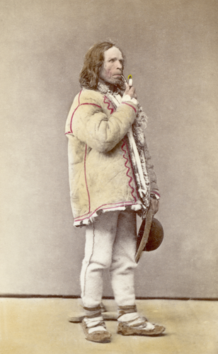
Wikidata link: http://www.wikidata.org/entity/Q119224500
Title: David Popper
Year: 1873-01-01T00:00:00Z
Creator: Julian Ganz
Collection: Bpk-Bildagentur
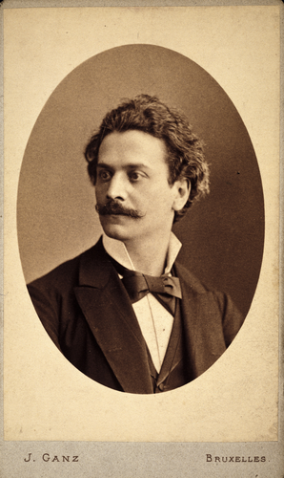
Wikidata link: http://www.wikidata.org/entity/Q119224502
Title: Max Bruch
Year: 1895-01-01T00:00:00Z
Creator: Adolf Halwas
Collection: Bpk-Bildagentur
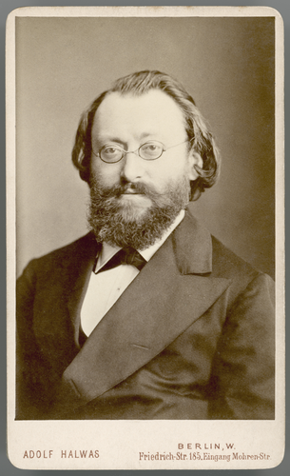
Wikidata link: http://www.wikidata.org/entity/Q119224503
Title: Gerhart Hauptmann
Year: 1889-01-01T00:00:00Z
Creator: Jakob Baruch
Collection: Bpk-Bildagentur
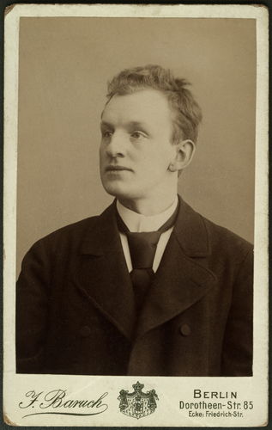
Wikidata link: http://www.wikidata.org/entity/Q119224504
Title: Hermann Ludwig Ferdinand von Helmholtz
Year: 1881-01-01T00:00:00Z
Creator: Jacob Reichard
Collection: Bpk-Bildagentur
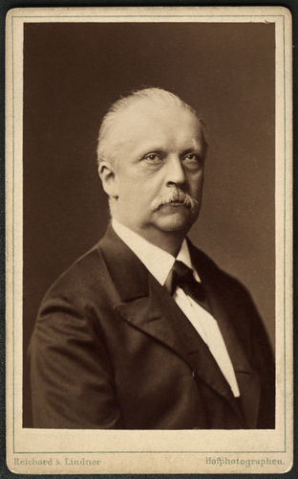
Wikidata link: http://www.wikidata.org/entity/Q119224506
Title: “Old gentleman” with student cap
Year: 1910-01-01T00:00:00Z
Creator: Fritz Krauskopf
Collection: Bpk-Bildagentur
